Experiment 1graph:
- Y-axis (PPM): Parts per million; higher ppm = more target gas.
- Pipeline: ADC → Vout → Rs = RL·(5−Vout)/Vout → (Rs/R0) → PPM.
- Terms: Rs = sensor resistance (drops with more gas); R0 = clean-air baseline (from calibration); RL = fixed load resistor.
- Meaning: Rs/R0 shows overall gas effect (mixture). PPM is a per-gas estimate using a fitted curve.
- Curves used:
MQ-2 ≈ 50·(Rs/R0)^−2.3 (hydrocarbons/Ethylene);
MQ-4 ≈ 1000·(Rs/R0)^−2.95 (Methane).
- Reading the graph: More gas → lower Rs/R0 → higher ppm. Peaks = gas bursts; flat/low = clean or stable air.
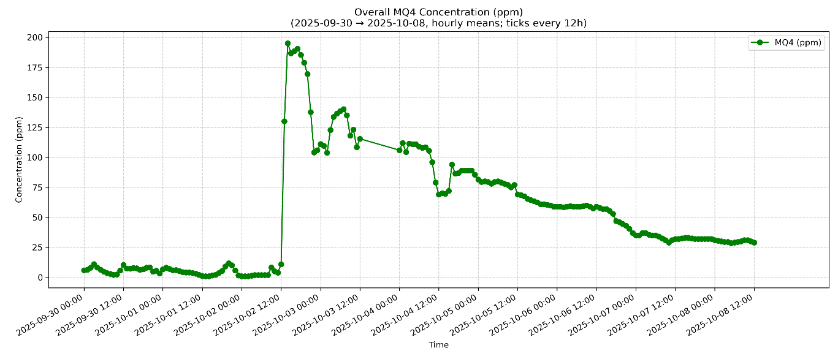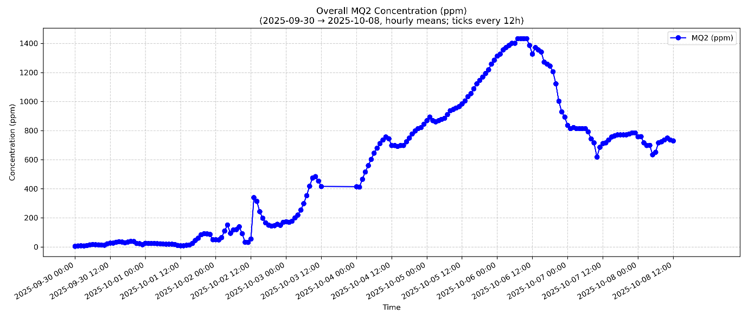

Experiment 2 graph:
- Y-axis (PPM): Parts per million; higher ppm = more target gas.
- Pipeline: ADC → Vout → Rs = RL·(5−Vout)/Vout → (Rs/R0) → PPM.
- Terms: Rs = sensor resistance (drops with more gas); R0 = clean-air baseline (from calibration); RL = fixed load resistor.
- Meaning: Rs/R0 shows overall gas effect (mixture). PPM is a per-gas estimate using a fitted curve.
- Curves used:
MQ-2 ≈ 50·(Rs/R0)^−2.3 (hydrocarbons/Ethylene); MQ-4 ≈ 1000·(Rs/R0)^−2.95 (Methane).
- Reading the graph: More gas → lower Rs/R0 → higher ppm. Peaks = gas bursts; flat/low = clean or stable air.
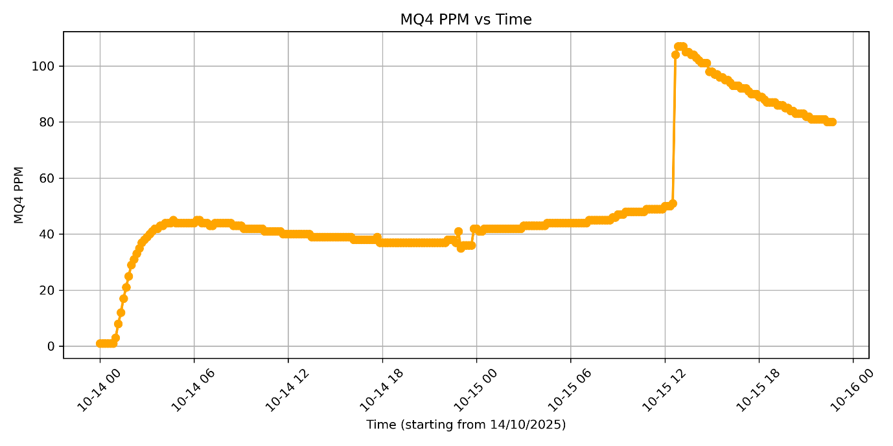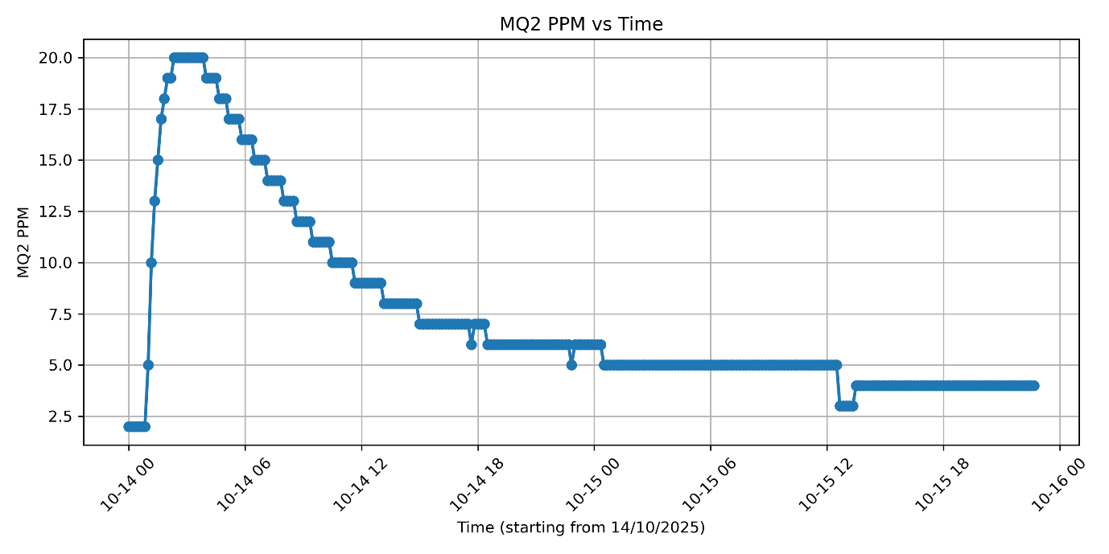
Experiment 3:
• Y-axis (Gas Index 0–100): Higher index = more target gas.
• Pipeline: ADC → Vout → Rs = RL·(5/Vout − 1) → (Rs/R0) → GasIndex.
• Terms: Rs = sensor resistance (drops with more gas); R0 = clean-air baseline (from calibration); RL = fixed load resistor.
• Meaning: Rs/R0 captures overall gas effect (mixture). GasIndex is a normalized, human-friendly scale (not gas-specific ppm).
• Mapping used:
RS/R0 ≥ 1.0 → GI=0; 0.6→≈40; 0.3→≈80; ≤0.1→100 .
• Reading the graph: More gas → lower Rs/R0 → higher GasIndex. 